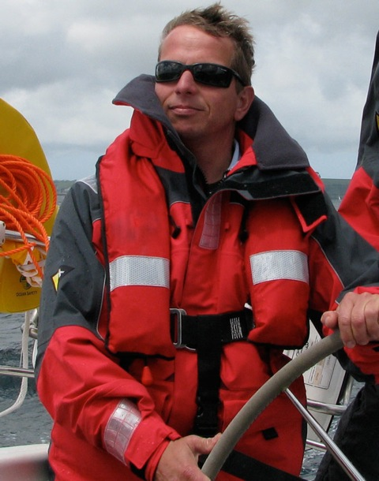

Richard Pyshorn FRGS - BIO

Richard Pyshorn is the Director of Secure Forests a not for profit Community Interest Company, established to try and support indigenous local people around the globe fight the illegal Forestry and wildlife trades. Richard is passionate about trying to help people protect and conserve, incredible and important habitats

Formerly for 30 years as a Force Protection specialist in the UK armed forces. Specialising in protection of high value assets in threat environments around the world. Having experience of 10 operational tours of duty. He has survived in environments from the Middle East to Central American jungles, having completed some of the most arduous and toughest courses, within the British military. In 2012 he was deployed to Afghanistan to the Kabul Military training centre to train and mentor the Afghan National Army. He was appointed as the Regimental Sergeant Major to the Kabul Advisory Group, over 800 coalition trainers and advisors. There he was a senior manager responsible for the safety, administration and logistics of over 800 men and women from 18 different coalition countries. Ensuring their administration and operational safety, where of the highest standards.

Richard was the First Training Manager of the UK Defence Survival Evasion Resistance Extraction Organisation (DSTO) at RAF St Mawgan. He was responsible for the management and logistics of all courses at the school ranging from Maritime Sea Survival training to Advanced Escape and Evasion courses. His specialist knowledge and many years of experience of the Jungle environment, has seen him deploy regularly to support and run expeditions in the jungles of Belize in Central America and West Africa. Richard has run expeditions throughout the globe to countries such as Europe, Canada, America, Malaysia, Africa and the Middle East.

Along with many operational awards and citations, in 2013 in recognition of a very full and rewarding career he was asked to become a Fellow of the Royal Geographical Society. A privilege that goes beyond words and is shared with Fellows such as Michael Palin and numerous incredible adventurers throughout history. A true honour and privilege to become a qualified and appointed trainer for this historical and inspirational institution.

Richard enjoys any outdoor pursuits including Offshore sailing, Trekking and Hill walking. He also enjoys having a laugh with his mates in the Rod and Line Pub in his home in Cornwall.

Testimonials:

Experienced Offshore / Onshore Aviation Safety Assurance Consultant

“I had the great privilege of working with Richard during the reorganisation of a major military unit, delivering core and advanced tactical survival skills to all members of the UK armed forces and government services. His tenacity, management skills, intelligence but moreover his passion for delivering survival training was simply outstanding.”

Station Commander; Commander RAF Regiment; Deputy Force Protection Force Commander at Royal Air Force

“In addition to a period directly managing Richard Pyshorn, I have also had regular exposure to his work in a number of other appointments. His performance was consistently high-grade and he was utterly reliable, as evidenced by his rapid promotion. He routinely demonstrated the ability to adapt to rapidly changing circumstances, whilst retaining focus. An excellent communicator, his character and proven leadership skills make him a vital team member. An impressive and well-rounded individual.”

