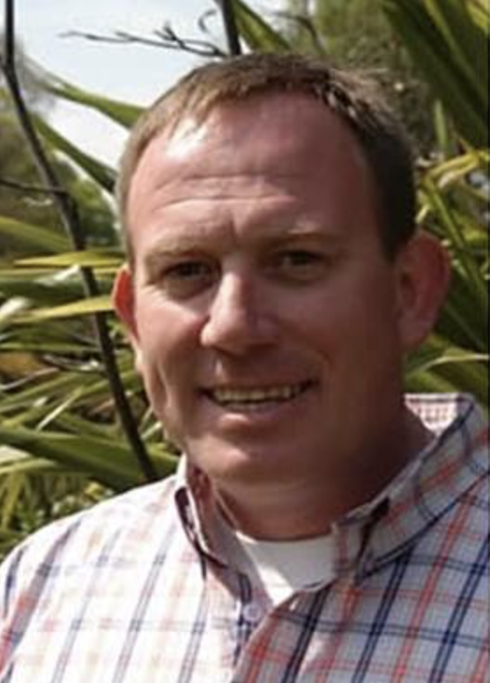

Chris Minty has spent much his adult life in Belize either working or travelling in the country. Following service in the British Forces, Chris left to pursue a career in science, starting by completing a Bachelor Degree in Ecology & Environment and then a Master’s Degree in Natural Resource Management at the University of Edinburgh. His love of fieldwork, inspired by Professor Peter Furley, was clear from the outset and he went on to lead and worked on a series of expeditions in Belize during the 90’s. In 1997, Chris joined London’s Natural History Museum as the resident manager at Las Cuevas Research Station in the Chiquibul Forest, Cayo. For 8 years Chris basically lived full-time in the bush – either at the Station in its remote setting in the forest or actually on expeditions. He has supported literally hundreds of science projects ranging from soil surveys and student study groups to the re-introduction of Harpy Eagles into the wild, he led the Wildlife Impact Assessment of the Macal River Upper Storage Facility (Chalillo Dam) and has sat on several Belize Government advisory panels. Chris pioneered live-webcasts from the remote jungle location back to the NHM, the San-Francisco Exploratorium and many other visitor centres and has appeared in several National Geographic documentaries. His outstanding achievements in Belize led to his being awarded the MBE in 2007 for services to the conservation of the Central American rainforest. Now as Chief Executive of The Silvanus Trust, a woodland conservation charity, Chris maintains close links with Belize leading private trips to the Chiquibul Forest and facilitating science and student expeditions whenever he can. He is an Associate Director of Full Basket Belize, a 501c entity in the US supporting grass roots conservation and education projects and he has been a committee member of the UK Belize Association since 1996.

